We’ve had reports from some of you that when you go to modify a patron’s address, you see this error pop up:

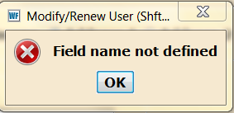

And are then unable to save the patron’s information.

What’s happening is that these are usually patron records that were migrated over from DRA to Sirsi back in 2004: you may see that some of them have COUNTY and other fields we no longer use.

In this case, there is also a blank field in the address information:
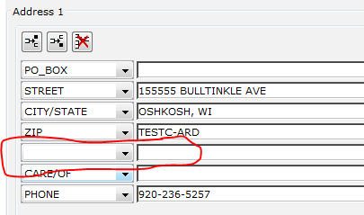
Note that the field name is blank, as well as the contents. The error “Field Name not defined” indicates that there is one of these blank fields in the user record.

The technical reason for this is that there used to be information in this field which we removed at some point. Workflows remembers that there should be information, but because the field name is blank, can’t tell where to put that information in the user record.

It is very easy to fix. Click into the field as if you were going to enter data, then go up and click the red ‘X’ icon above the address information (the “Field Remove Helper). This is the only way to delete the field entirely.

When the field is removed, you will be able to save the user information as normal.

